Question 14

Try Static NAT, Dynamic NAT and PAT to translate Ips

Make the below given network

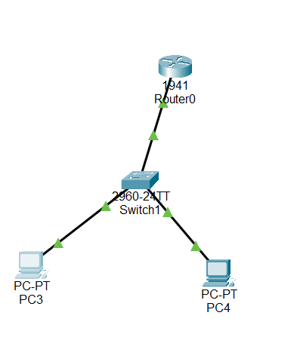

Now configure swith and create vlan’s

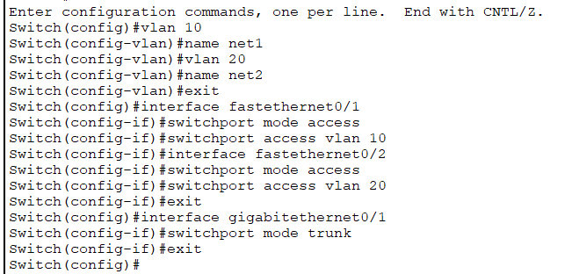

Now configure the router to communicate between inter vlan

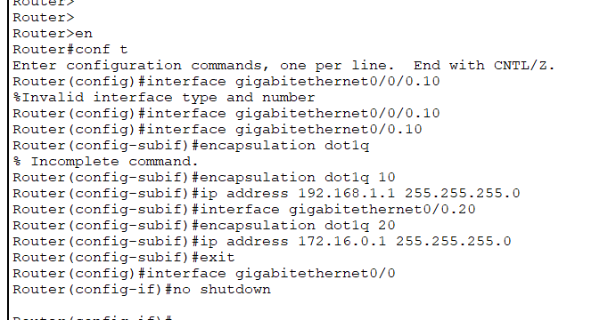

Now if you try to ping another network it works.

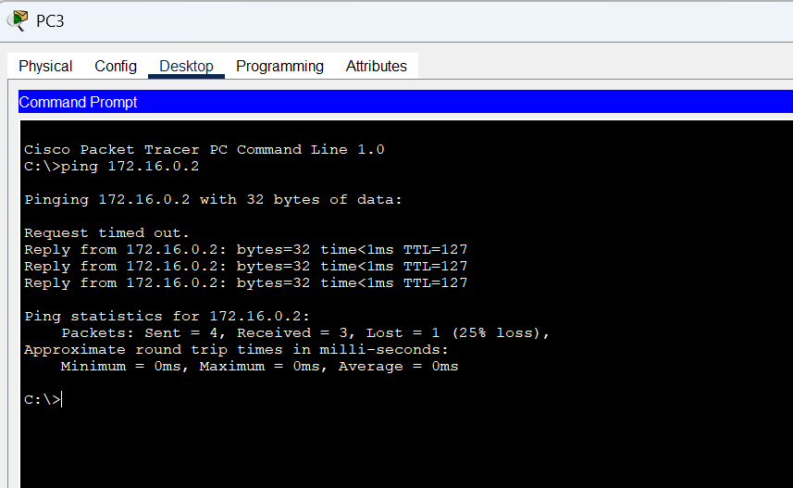

Now configure for Static NAT

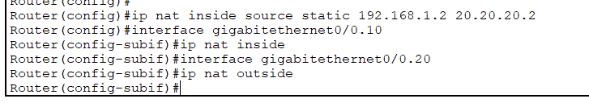

The packet’s source IP after nat

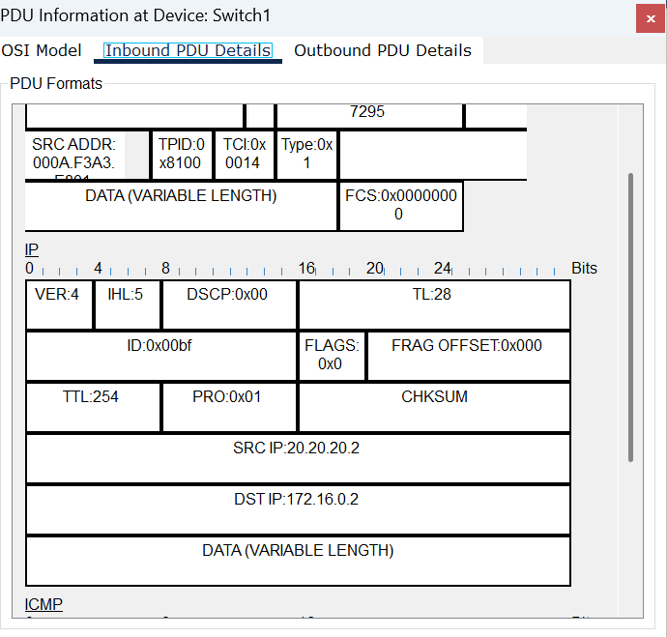

Dynamic nat

Create a pool of public nat



Add source list and add nat to the network



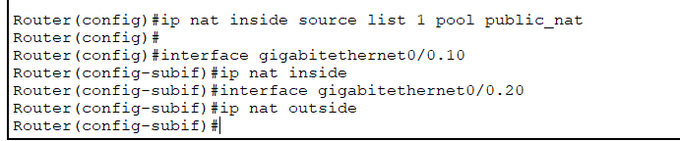

Now you can check the arp packet has assigned public ip

